BalajiFOOD Sales Queries doc

1. Total Revenue: SELECT SUM(transaction_amount) AS Total_Revenue FROM BalajiFastFoodSales

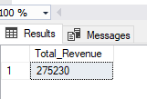

1. SELECT SUM(transaction_amount) / COUNT( DISTINCT order_id) AS Average_Order_Value FROM BalajiFastFoodSales

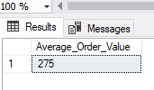

1. SELECT SUM(quantity) AS Total_Items_Sold FROM BalajiFastFoodSales

1. Total Orders Placed: SELECT COUNT(DISTINCT order_id) AS Tota_orders_Placed FROM BalajiFastFoodSales

1. Average items per order: SELECT CAST(CAST(SUM(quantity) AS decimal(10,2)) / CAST(COUNT(DISTINCT order_id) AS decimal(10,2)) AS decimal(10,2)) AS Average_Items_Per_Order FROM BalajiFastFoodSales

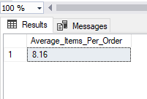

SELECT DATENAME (DW, date) AS Order_Day, COUNT(DISTINCT order_id) AS Total_Order_Daily FROM BalajiFastFoodSales

1. GROUP BY DATENAME (DW, date)

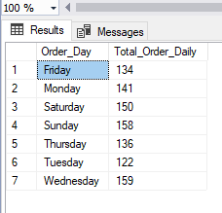

6.Monthly Trend: SELECT DATENAME (MONTH, date) AS Month_Name, COUNT(DISTINCT order_id) AS Total_Order_Monthly FROM BalajiFastFoodSales

GROUP BY DATENAME (MONTH, date)

7. SELECT item_type, SUM(item_price)*100/ (SELECT sum(item_price) FROM BalajiFastFoodSales) AS Item_Type_Percent

FROM BalajiFastFoodSales

GROUP BY item_type

8. SELECT item_name, CAST( SUM(item_price)*100/ (SELECT sum(item_price) FROM BalajiFastFoodSales) AS decimal(10,2)) AS Item_Name_Percent

FROM BalajiFastFoodSales

GROUP BY item_name

Order BY Item_Name_Percent DESC

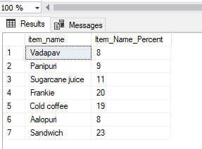

9. SELECT TOP 5 item_name, SUM(item_price) AS Total_Revenue FROM BalajiFastFoodSales

group by item_name

Order by Total_Revenue Desc

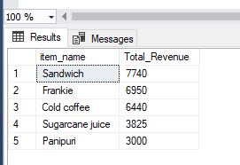

10. SELECT TOP 5 item_name, SUM(item_price) AS Total_Revenue FROM BalajiFastFoodSales

group by item_name

Order by Total_Revenue ASC

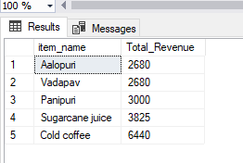

11. SELECT TOP 5 item_name, SUM(quantity) AS Total_Quantity FROM BalajiFastFoodSales

group by item_name

Order by Total_Quantity DESC

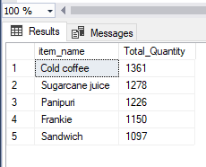

12. SELECT TOP 5 item_name, SUM(quantity) AS Total_Quantity FROM BalajiFastFoodSales

group by item_name

Order by Total_Quantity ASC

